**COLLECTION NOTES**

1. Go to the Customer File (AF1) and click on the book icon to add Notes

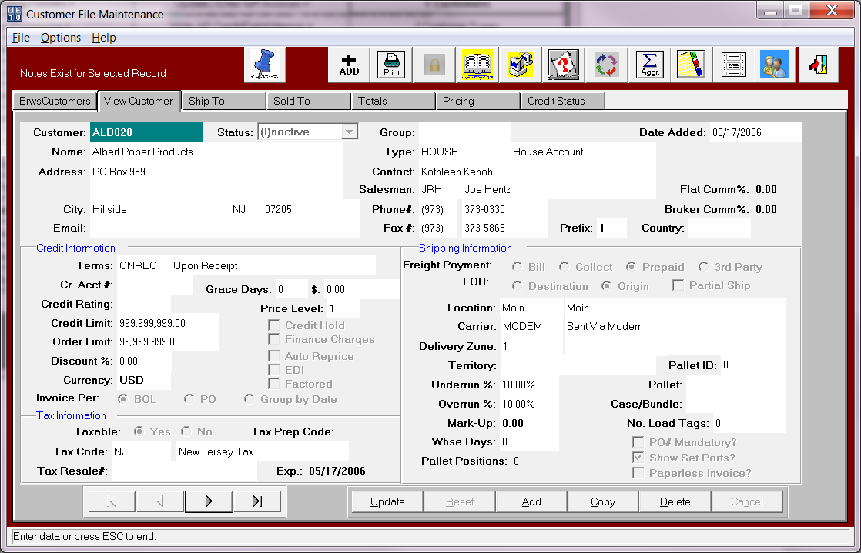

1. Click the ADD button and make sure you choose Note Type as Group and the Group must be COLLECTION. It must be spelled exactly like that in order for the notes to be brought into the aging. If you do not have that option on the F1 popup screen, you will have to go to the Network System Administration menu and add to the N-User Groups List

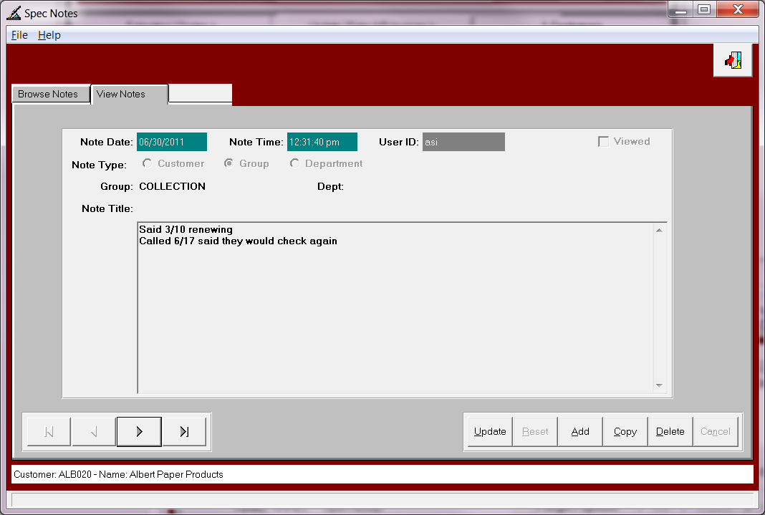

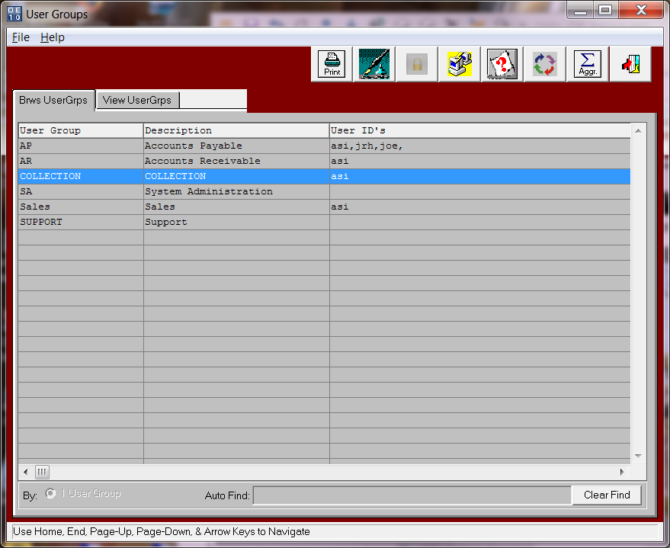

1. Once you have your Collection notes added you can then print them on the AR Aging Report. On the AR Aging print screen check the toggle box (Print Collection Notes).

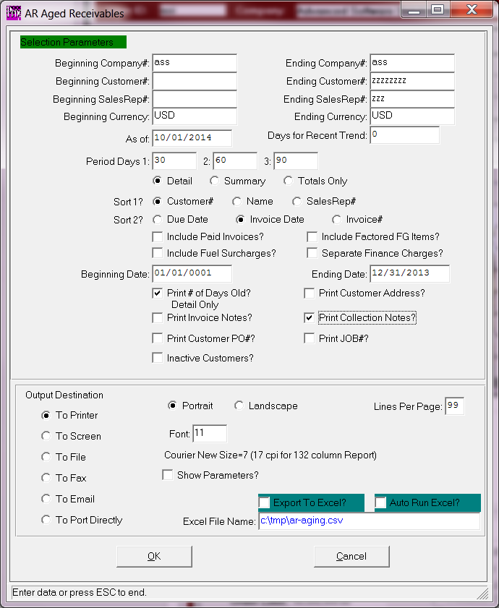

1. Your notes will then print underneath the customer name on the aging report.